To compile this library in Matlab you will need a C compiler and Mex function. So, let’s start with setting up Mex.

1.      Setting up Mex

If you have done this already, skip this part. Setting up Mex is very easy; all you have to do is to

* Get and install a Matlab supported compiler.
* Type mex -setup in Matlab’s command window press enter and then to locate compiler enter ‘y’, to select Compiler enter its number. Similar as in the figure below.

[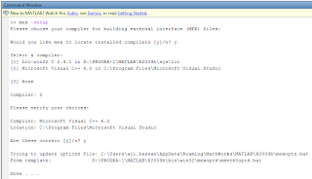](http://1.bp.blogspot.com/-zz5OnwpmRPM/UBPCrkM596I/AAAAAAAAACQ/5nSa_Gj1lxc/s1600/setup+mex.png)

Note: The list of compilers shown on your system might be different from the list shown in this example. The path names to your compilers might also be different.  To read more about Mex click [here](http://www.mathworks.com/help/matlab/matlab_external/building-mex-files.html#f23734)and [here](http://www.mathworks.com/help/matlab/matlab_external/introducing-mex-files.html)

2.      Download and extract the source code of this tutorial from [here](https://sites.google.com/site/thebrainiac1/resources/face%20detection.zip?attredirects=0&d=1)*,*set it to current working directory in matlab.

3.      Download SVM-Light from [here](http://sourceforge.net/projects/mex-svm/)

4.      Extract it into current working directory

[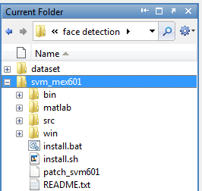](http://4.bp.blogspot.com/-DdFsmT2ia8o/UBPCaSMQowI/AAAAAAAAACA/kxsMTYV1Ib8/s1600/extract+mex.png)

5.      Add following paths to main file, demo.m in our case.

addpath './svm_mex601/matlab';

addpath './svm_mex601/bin';

6.      The library is precompiled; all binary files can be found in the ‘bin’ folder. Sometimes they work just fine but sometimes they cause problems, maybe due to compatibility and architectural issues. To compile them run compilemex()after adding the above paths.  compilemex.m  is located in the directory ‘matlab’ and resulting binary files should be stored in ‘bin’ directory. If compilemex fails then you would need to edit compilemex.m  as follows.

At line number 4 replace ‘cd bin’ to ‘cd svm_mex601/bin’ and add one more ‘cd ..’ after line 18 to point back to current working directory. As shown in the figure below

[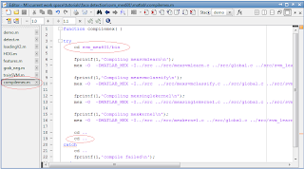](http://2.bp.blogspot.com/-LSFxZWgfGvk/UBPCmaZco5I/AAAAAAAAACI/PlkixghZxyk/s1600/compilemex1.png)

To run the compilemex insert break point after addpath lines as shown in the figure below, press F5 or click on the run button and when debugger stops at the break point run compilemex() through command window.

[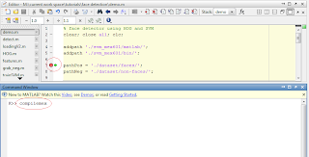](http://4.bp.blogspot.com/-pbYDlFTIW_U/UBPC50UvmWI/AAAAAAAAACY/J_ctWgWSrGc/s1600/compilemex.png)

This might show some warning but don’t worry everything will work fine, if it is compiled successfully.

7.      Run mex HoG.cpp [2] through command window to compile the HoG.cpp file.

That’s it, everything is now ready to run this face detection code. To do so run the demo.m, this will read an image and determine whether or not there is a face in that image.